Public Works Permit Application Types:

**PWorks Misc. Sewer**

**PWorks Misc. Water**

**PWorks Misc.**

*The permits above are not typically used. These permits are to only be used to track activities that do not occur during development. i.e. Inserta Tee installation, Hydrant Repair, Manhole Repair*

*The Following Permit Application Types are the most widely used:*

**PWorks Residential Permit**

**PWorks Commercial Permit**

**PWorks Blasting Permit**

**PWorks Land Disturbance Permit**

**Processing a Permit**

99% of the time when entering in a PWorks permit for the first time, you will want to attach it to a master project.

First, go to the activities catalog, click on master projects.

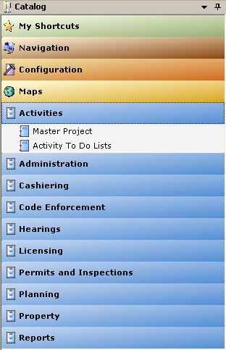

To find the master project, right click on the Name field to search for what you are looking for. Type in the name you are looking for -

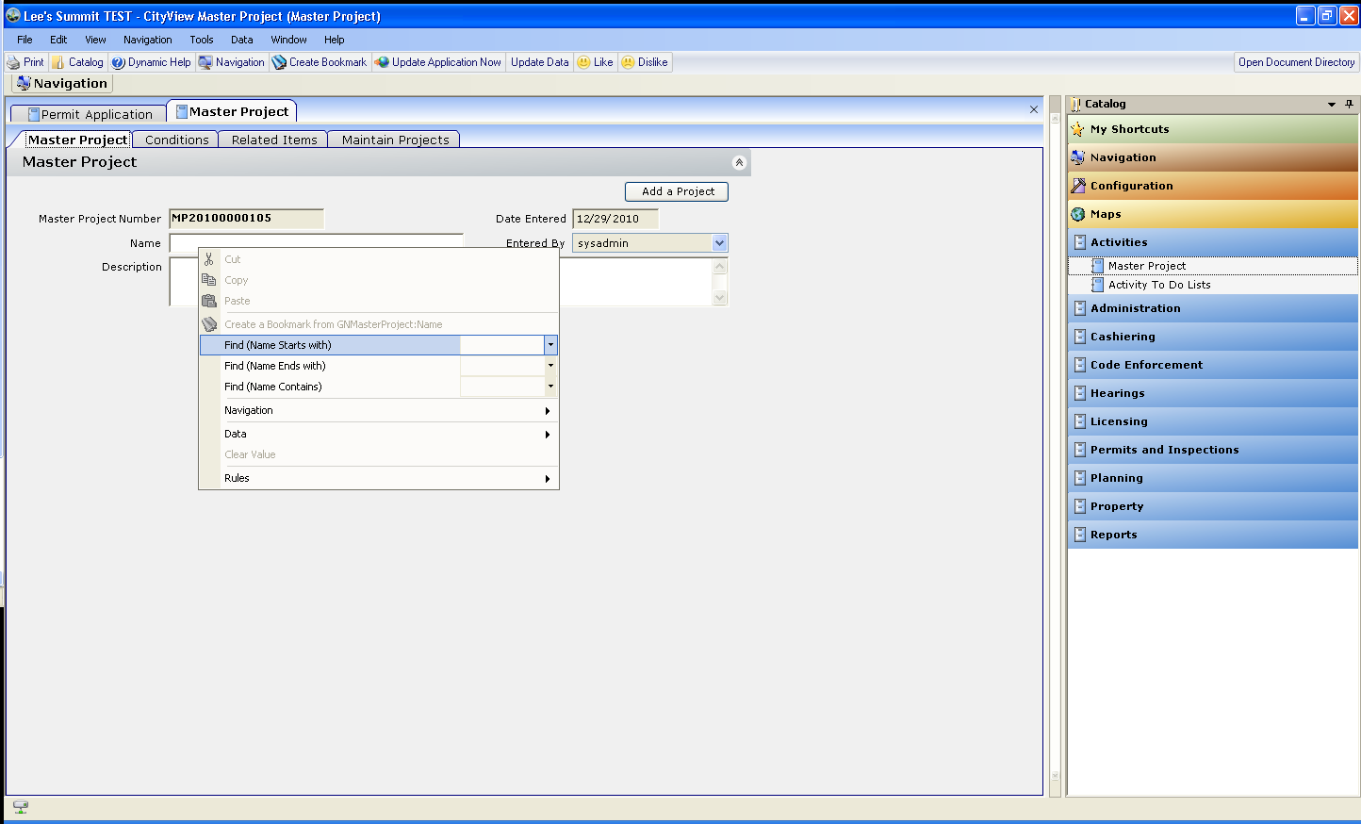

The navigation panel will pop down for you to select the name of the project you are wanting -

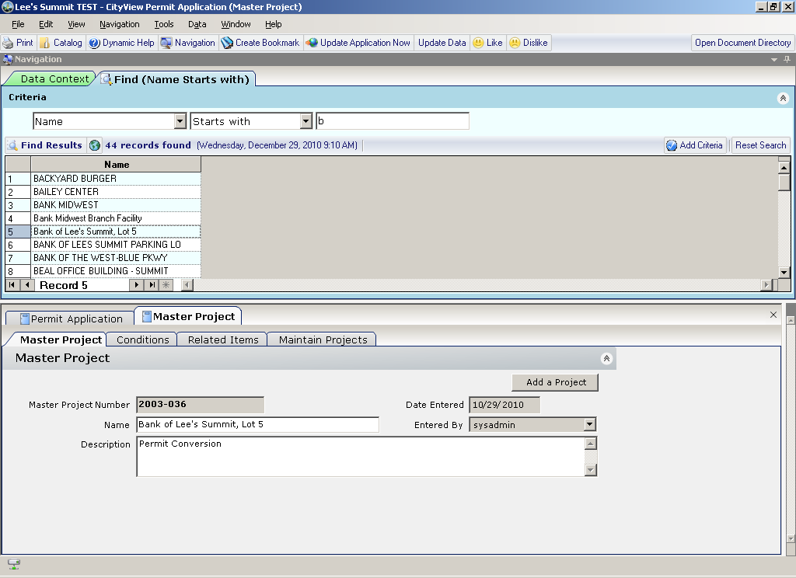

Then go to the Permits and Inspections Catalog and open the Permit Application Binder

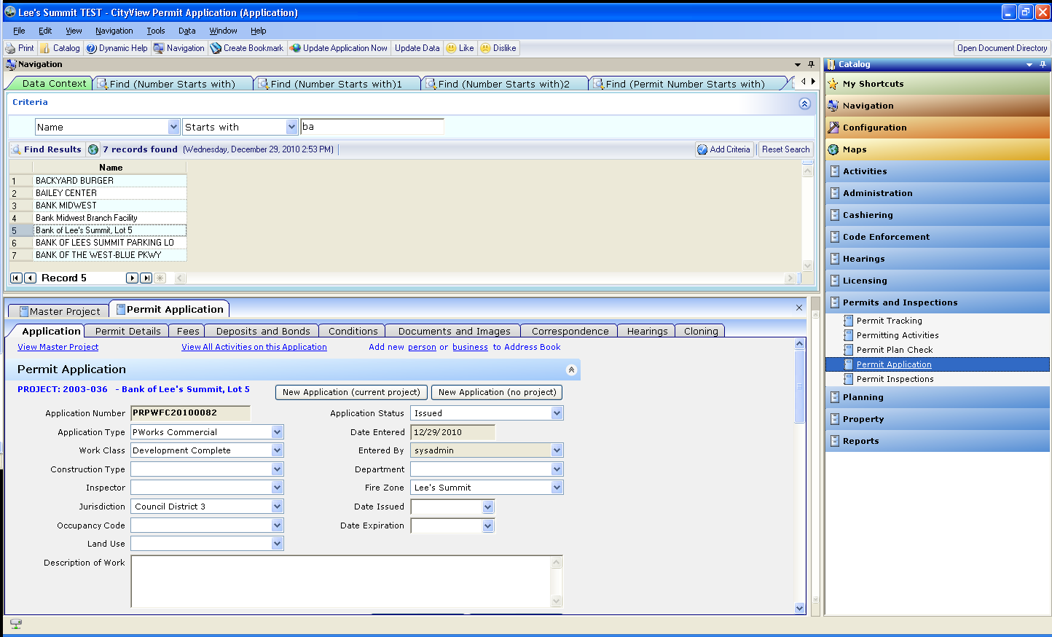

Once you are in this screen, if your navigation panel is still open, you can get rid of it by clicking the navigation button

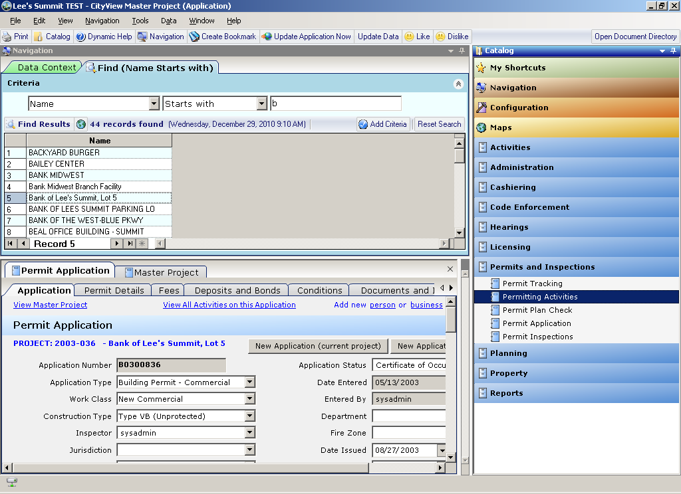

Next, click on the New Application (current project) button

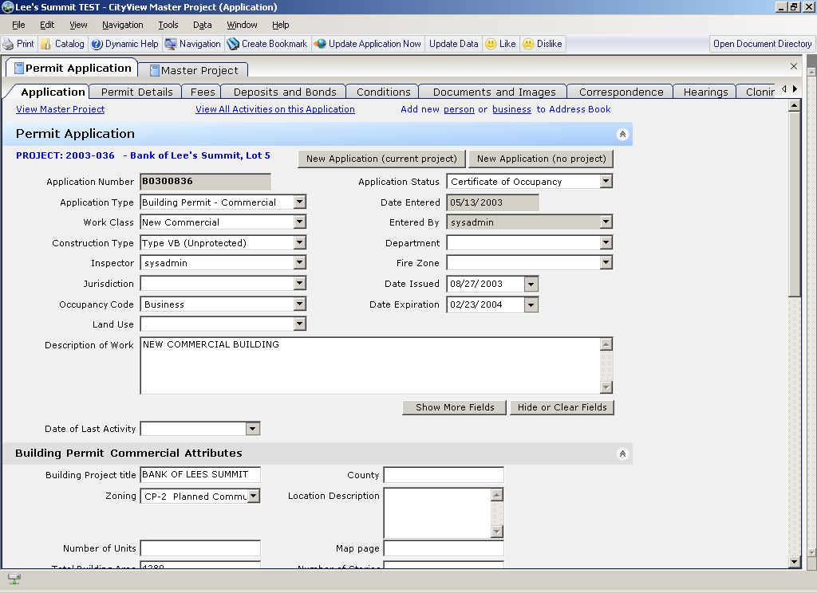

After choosing the permit type you need – (Typically Pworks Commercial or Pworks Residential)

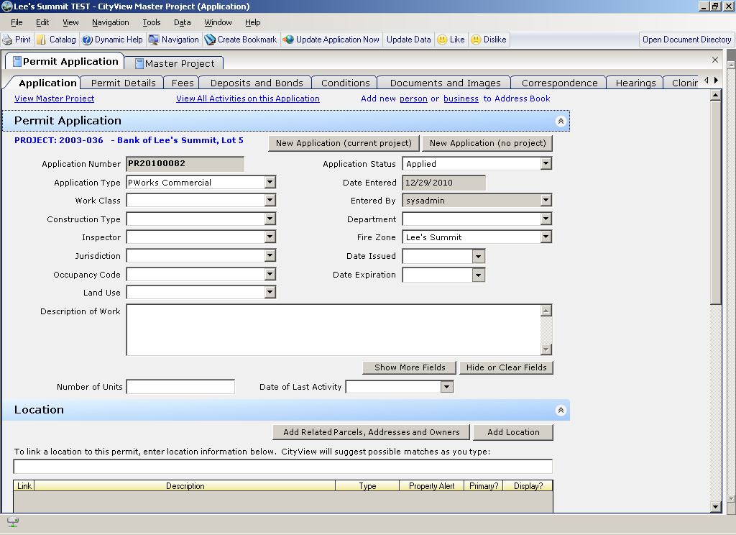

You will need to select a workclass –



See below for more information regarding workclass selections

Works Class determines what type of fees to charge and what inspections to add to the permit.

**Development Complete – water/sewer/storm/roads**

**Development Offsite –water/sewer/storm/roads**

**Development Public Works – storm/roads**

**Development Utilities – water/sewer/storm**

**Development Water and Sanitary – water/sewer**

**Misc. Water (Do not use this option)**

**Public Works Infrastructure**

**Sanitary Infrasturcture**

**Water Infrastructure**

**What information to fill out? If it doesn’t make sense to you, don’t fill it out –**

**Fill in the Inspector and maybe the description of work**

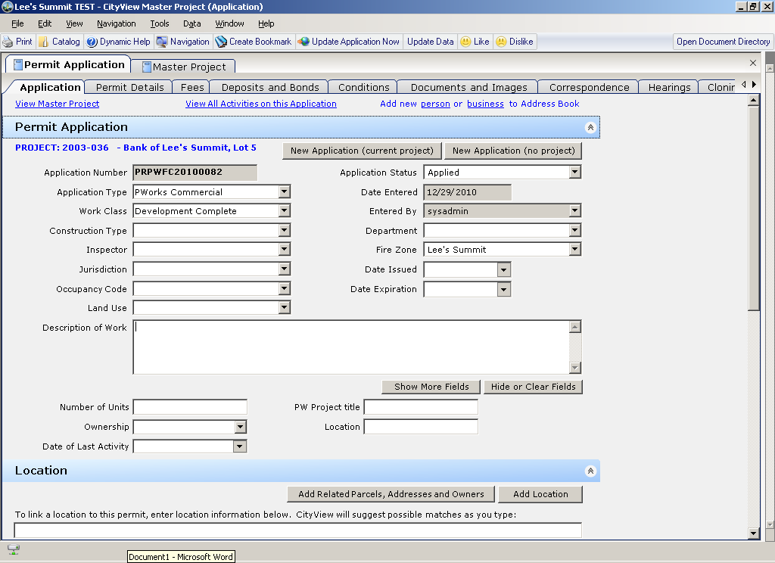

You might want to fill in the permit title

You could also fill in the ownership

The next pertinent information to add is the location –

First click the add location button –

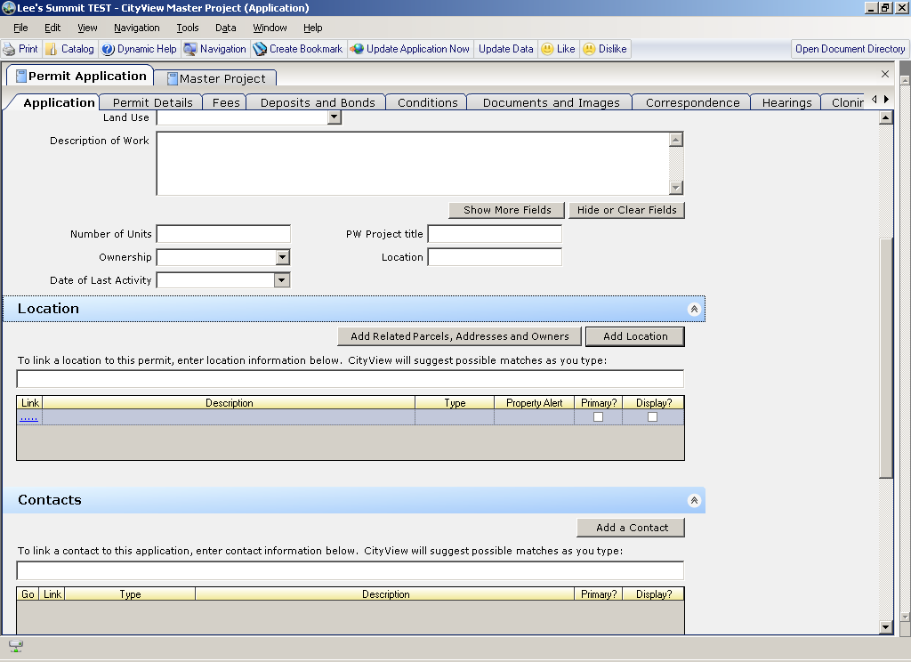

Then put your cursor in the white box and start typing an address or street name

Select the appropriate address, then you must click the add related parcels, addresses, and owners button - this will add the parcel and owner information.

After you click this button, you will notice several fields auto-populated on your screen. You will notice that the parcel owner info has now populated the contacts below –

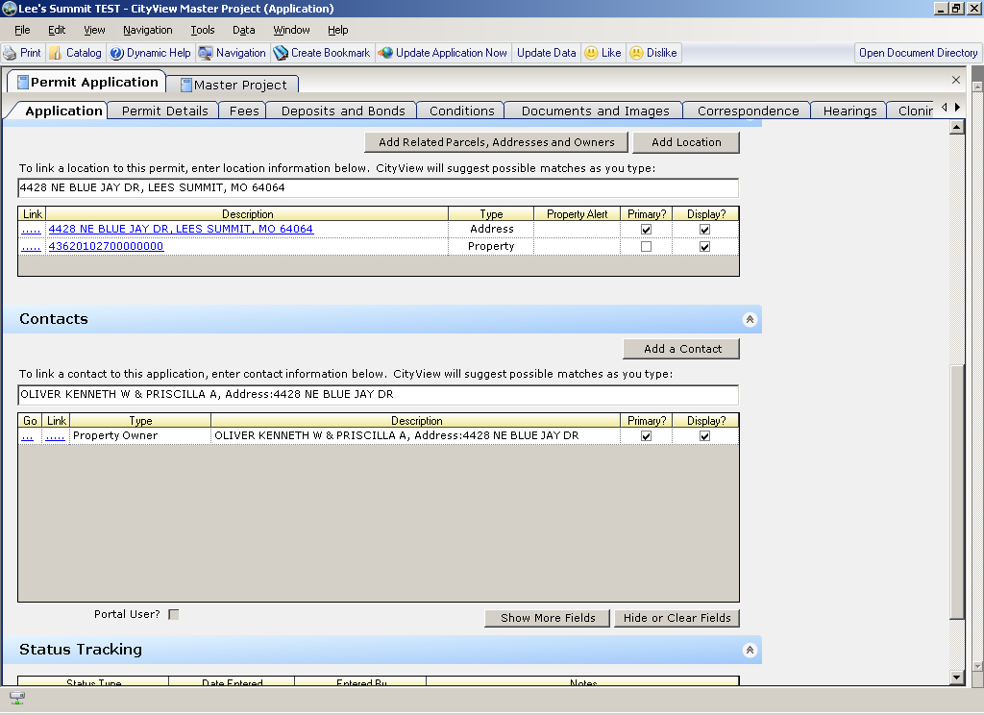

If you need to add another contact, such as the developer or contractor – you will need to hit the add contact button



Then put your cursor in the white box again to find your contact - start typing to see a list of contacts.

Some other fields you could see auto populated on the Permit Application sheet after hitting the add related parcels, address, and owners are:

Council District, Zoning, if there is a Development Agreement (all of this info comes from GIS map layers - based on the parcel location on the map.

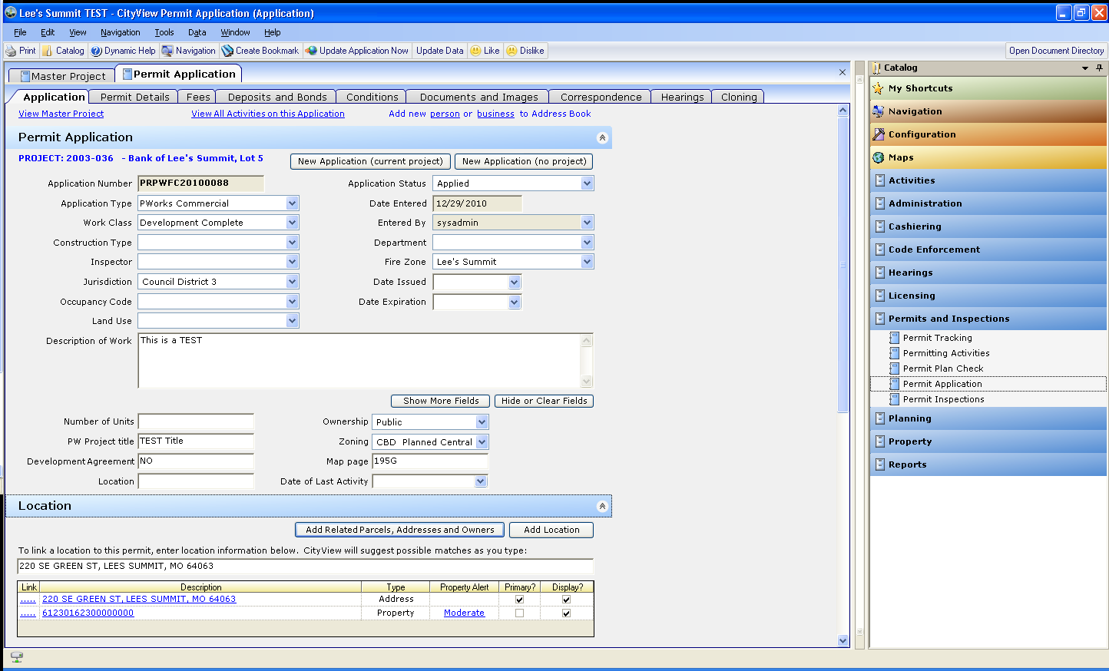

Next go to the permit details sheet

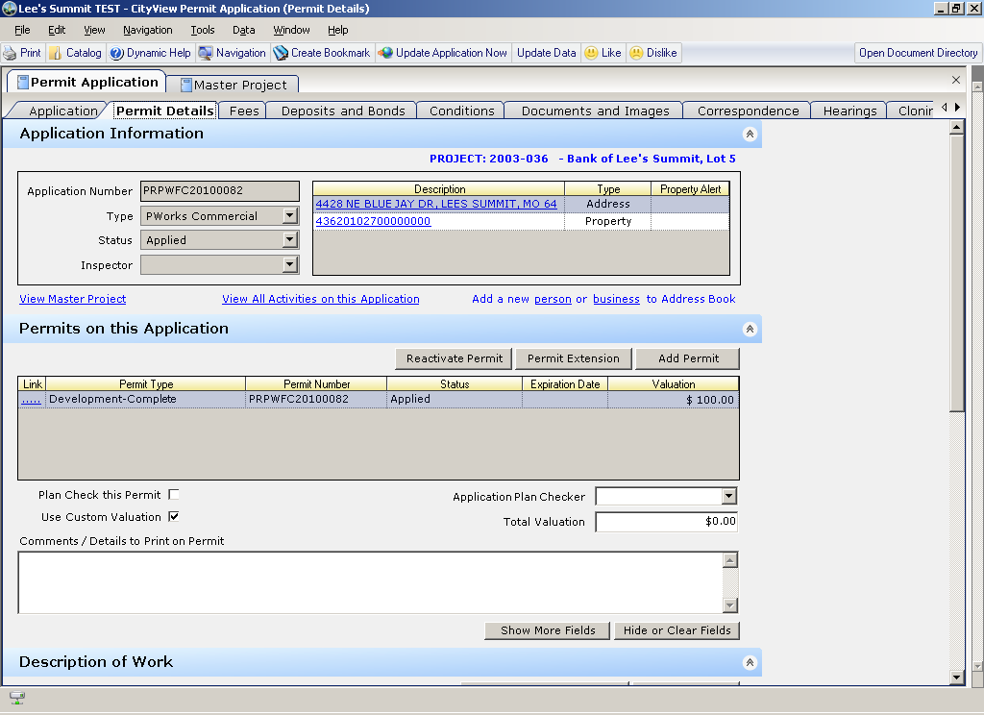

Scroll down to the Description of work

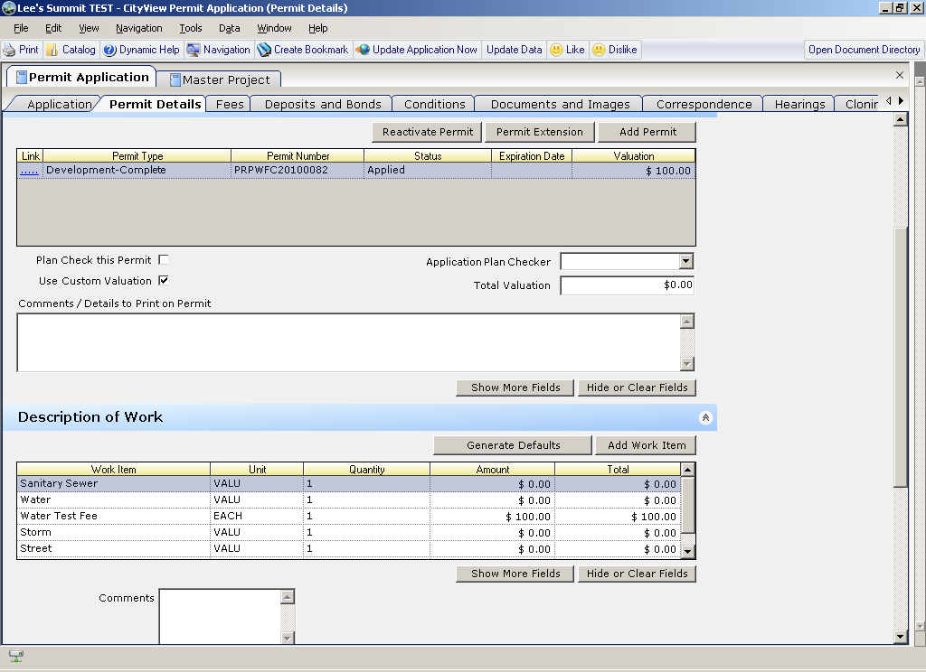

Make sure to manually enter the appropriate amounts

If it says valu - just enter the amount - If you see each – you will just need to enter the quantity - e.g. How many water tests?

If you need to enter a Description of work that is not there – you will need to click on the “add work item” button

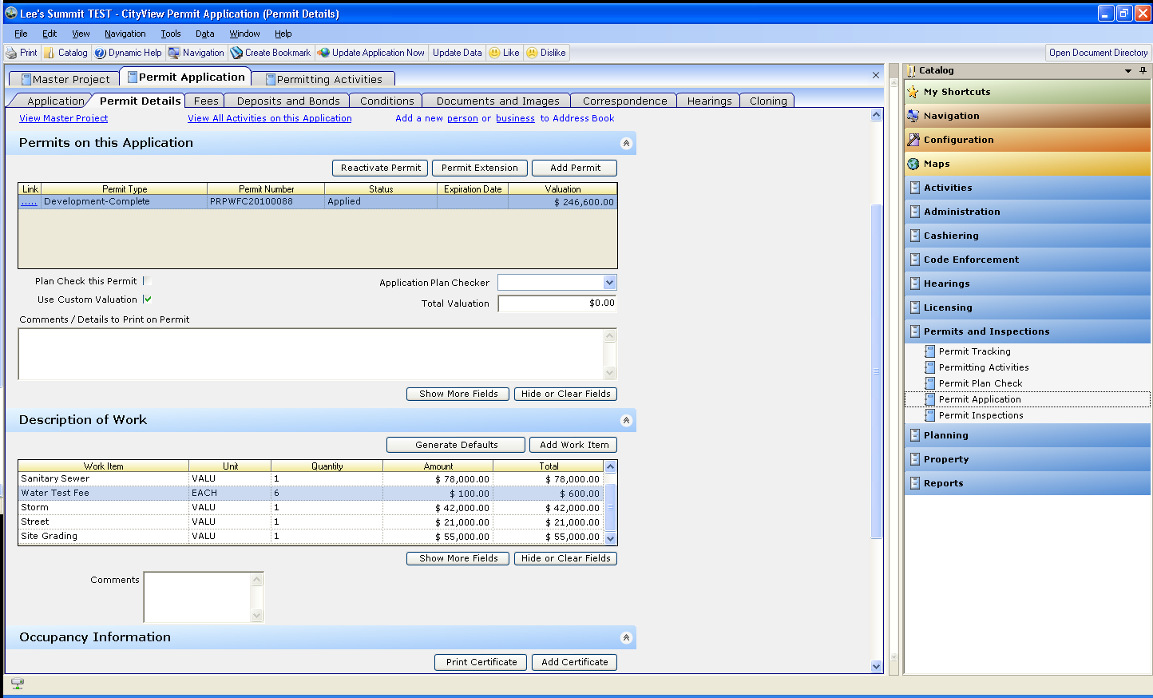

After entering the amounts you need, you will need to hit the generate defaults button



Notice – once you have hit generate defaults, the valuation amount will change

The generate defaults button is what adds the fees for you to collect payment on later.

Now you need to start working from the Activities Grid. Simply scroll up a little in the Permit Details sheet and click on the “View all activities on this application” link

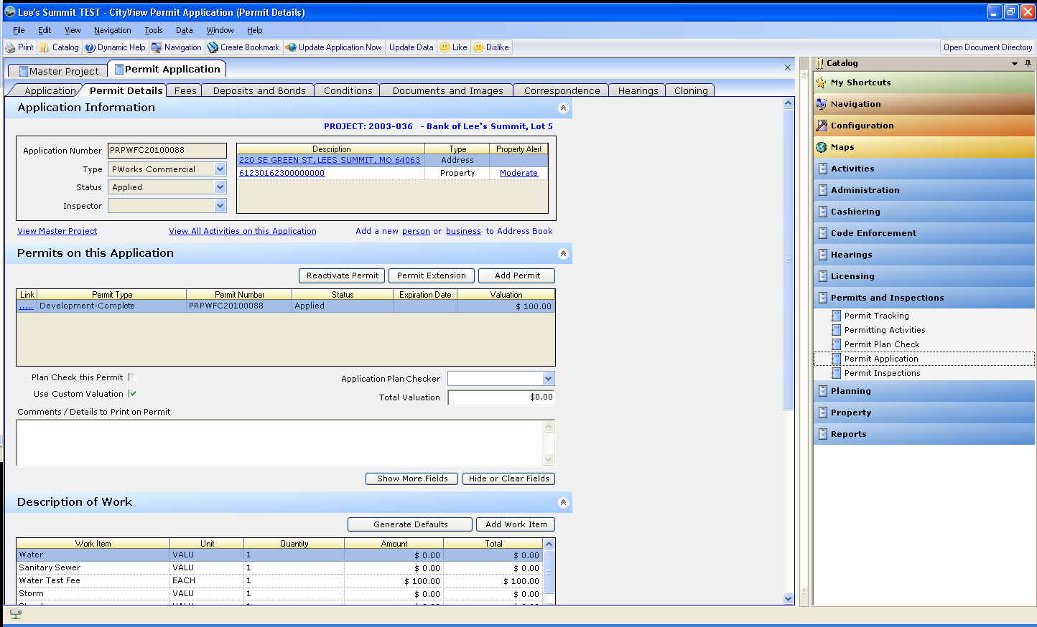

This will now open up the Permit Activities Binder

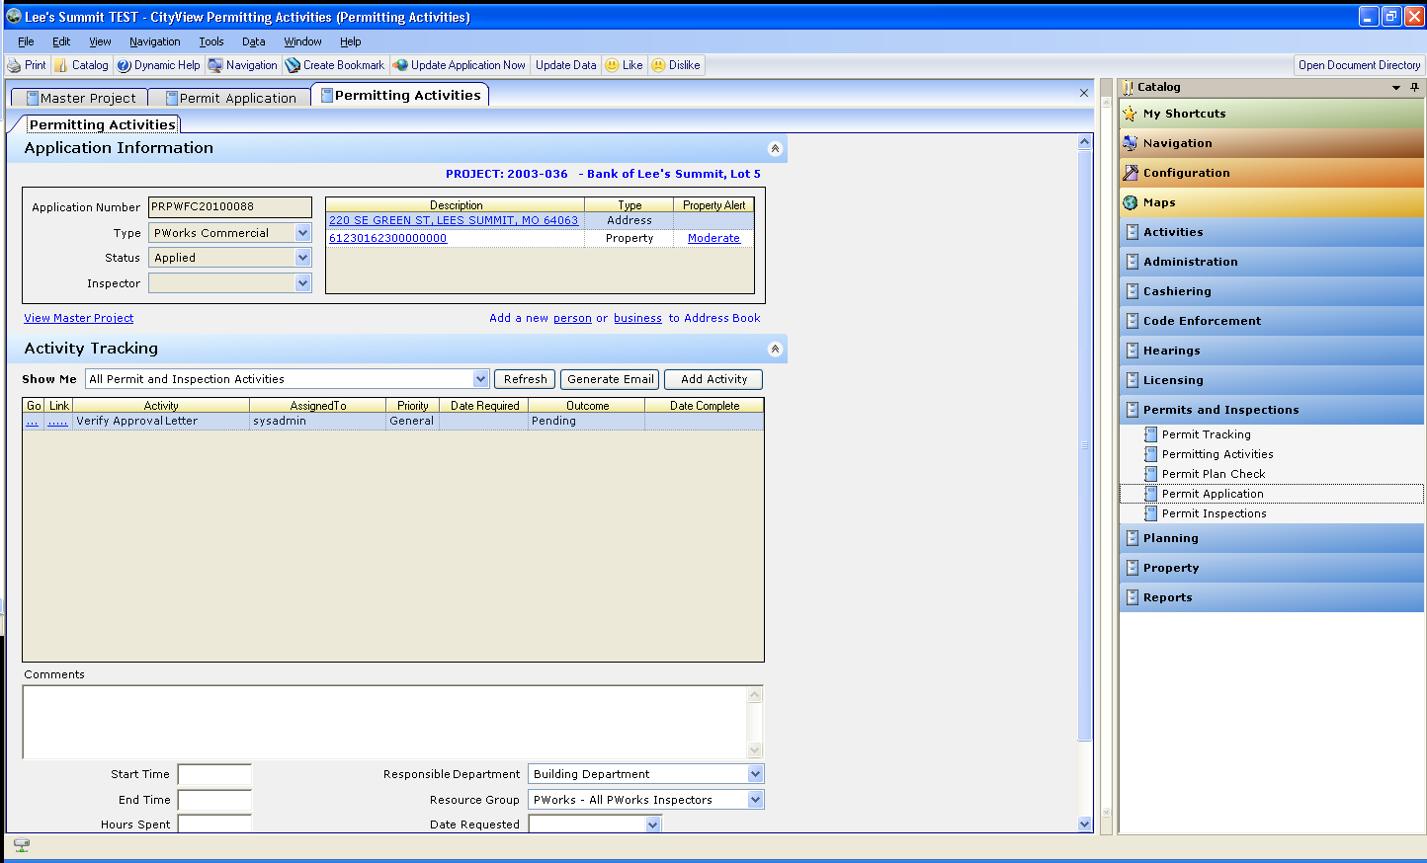

The first activity you see is Verify Approval letter - (outside of CityView function)

Simply click the “outcome” dropdown box to select complete

Once you complete this item, you will see another activity item pop up –

Verify Permits (outside of CityView function) Simply click the “outcome” dropdown box to select complete

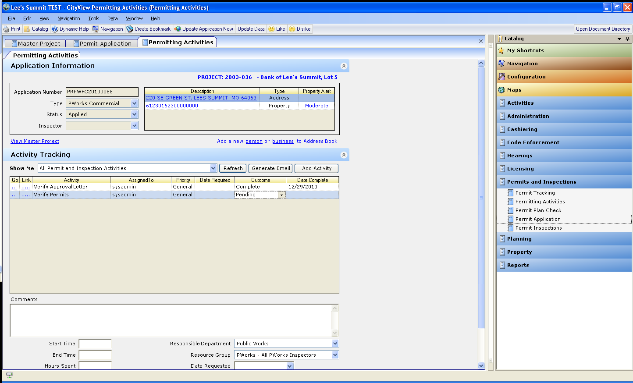

Now you will see another activity item pop up - Collect Public Works Fees - this activity is a function within CityView, so you will need to click on the “go” blue bar

This will automatically take you to the “Fees” sheet within the Permit Application Binder, so that you can take the payment.

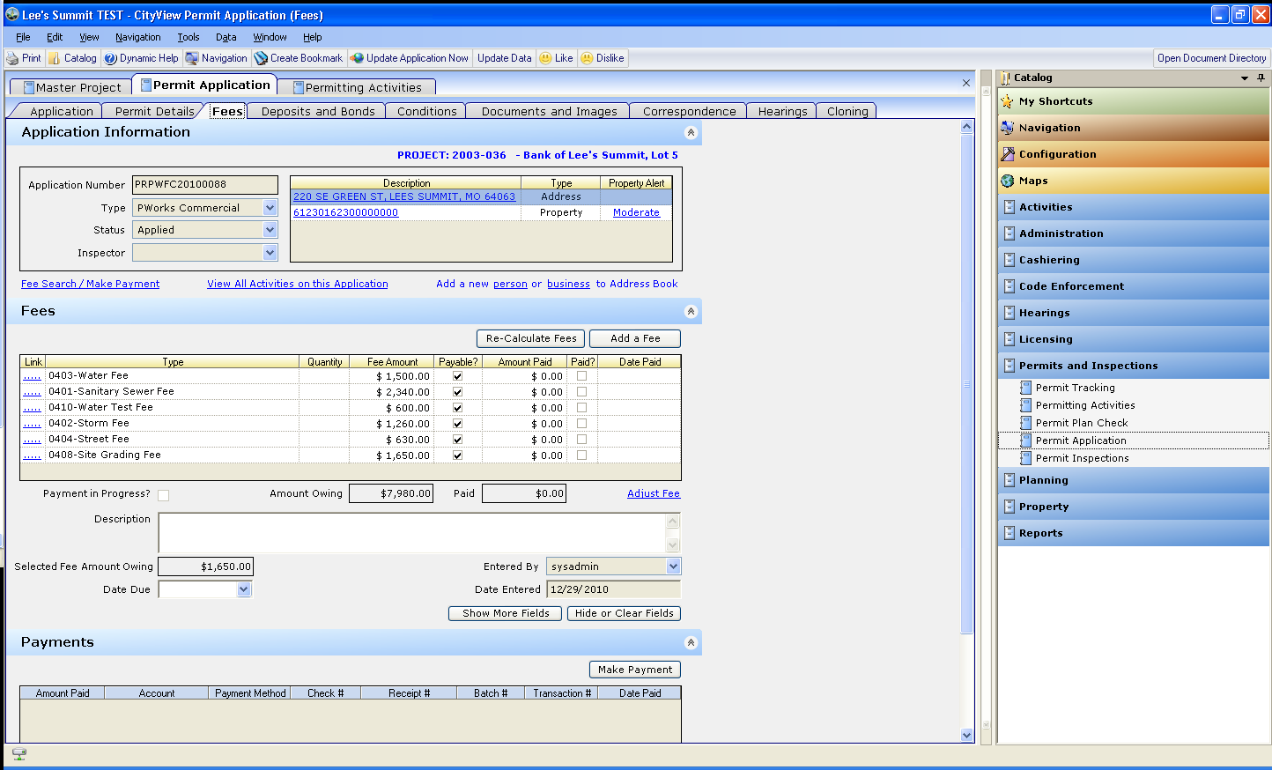

In the fees sheet, you will see all of your fee items



To make a payment, simply click the make payment button

This will now open up the Cashiering Binder

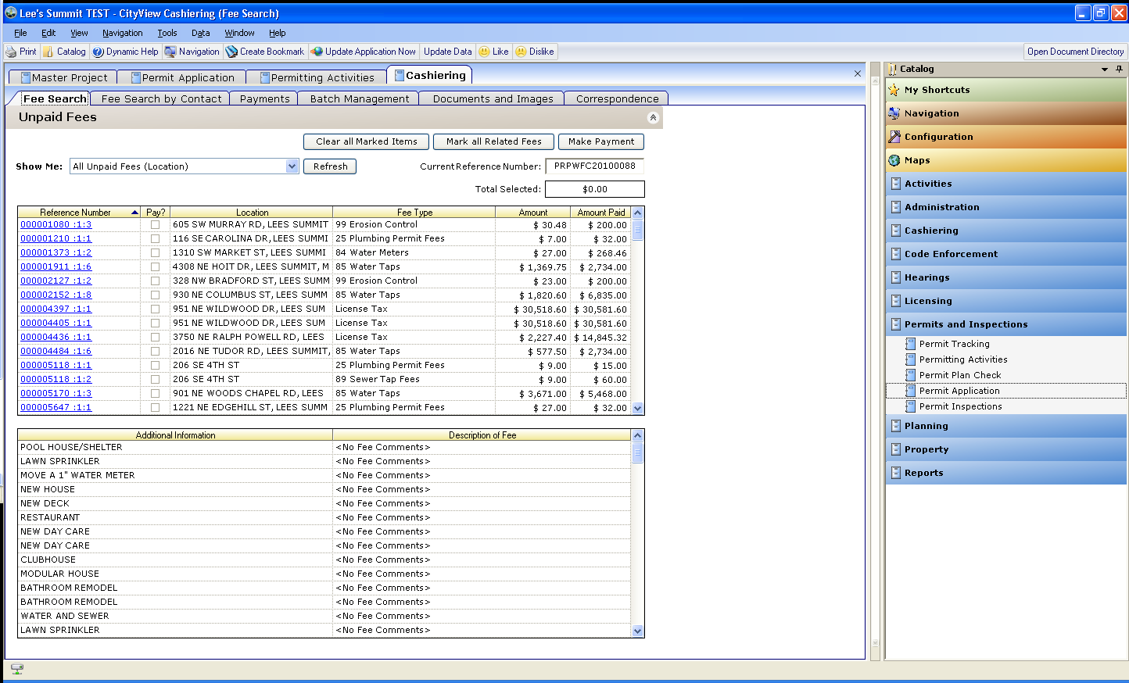

You will need to change the “show me” dropdown box to say:



This will show you only the fees that are associated to the application you have been working in –

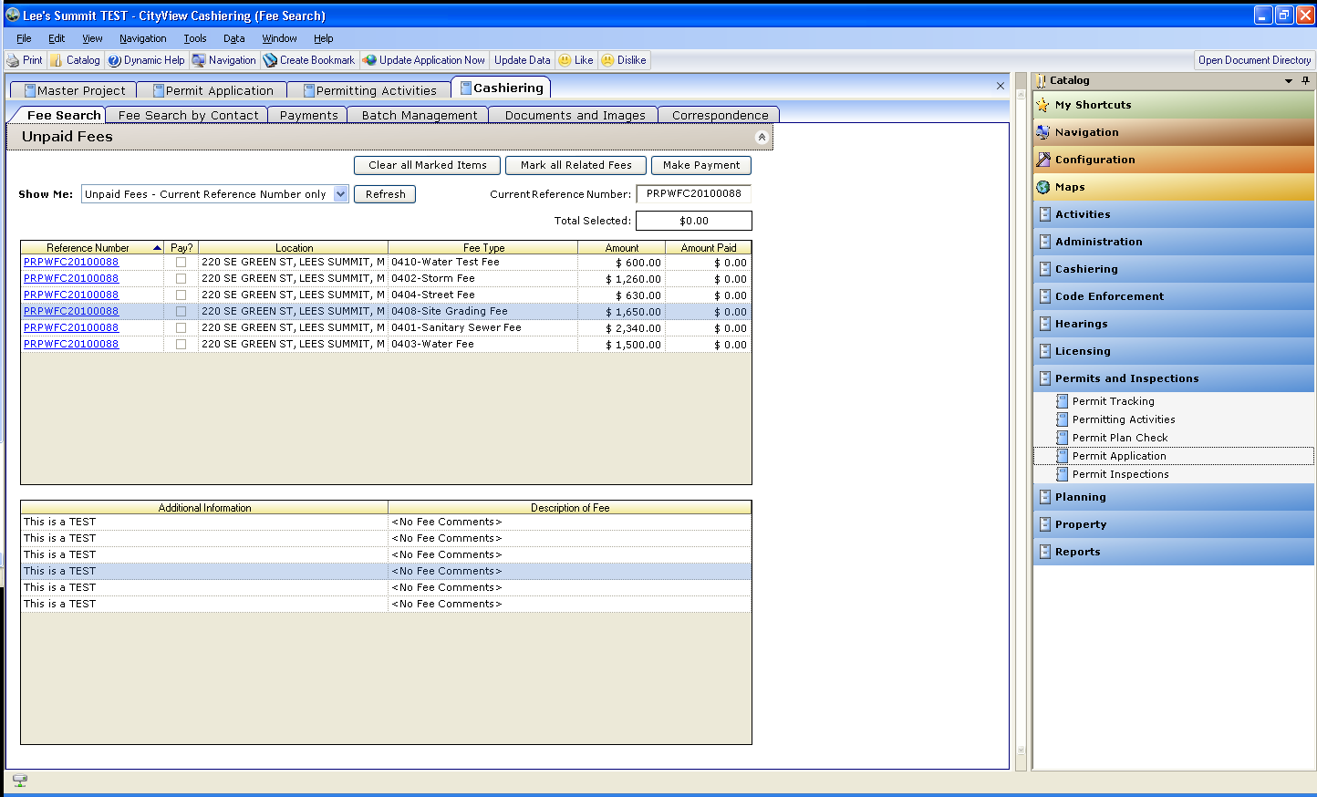

You will now need to check the “pay” box next to each fee you are wanting to pay

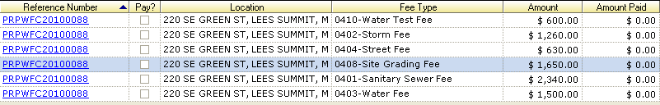

It shows you what each fee type is and what the amount is Most likely, you will check all of them.

Then click the make payment button

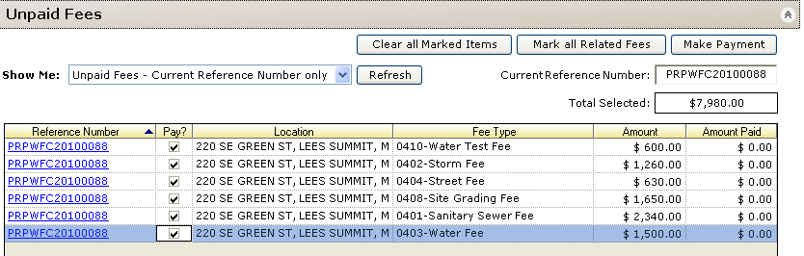

This now takes you to the payment sheet within the Cashiering binder

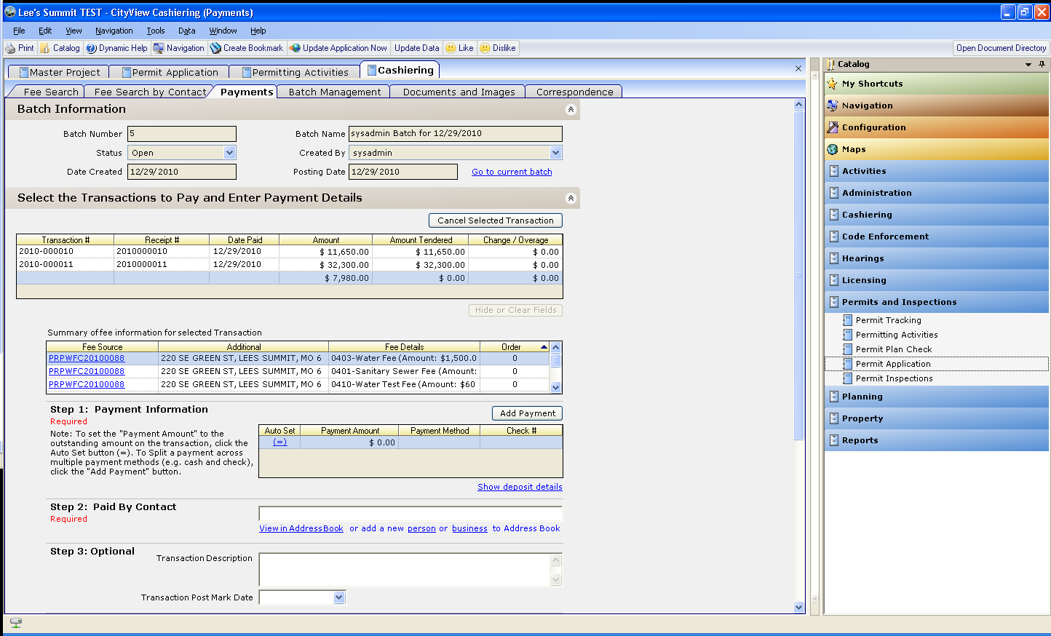

It is easiest to just follow the steps - Step 1, Step 2, Step 3, and Step 4.

Step 1 - If you are collecting the entire amount, you can simply click the “auto set” blue button - this will automatically bring your amount in for you.

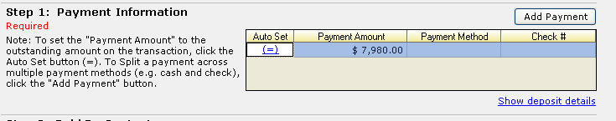

Now you can click in the “payment method” box to enter this info and the check #

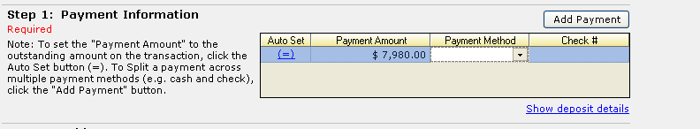

Step 2: Enter the contact information - simply start typing the contact name in the white box to begin the search for the contact who is paying.

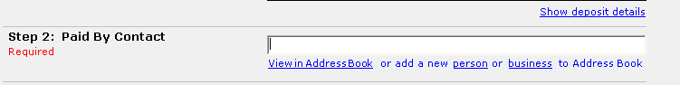

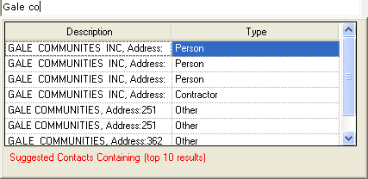

Select your contact by clicking it.

Step 3: is optional – If you want to enter info for this

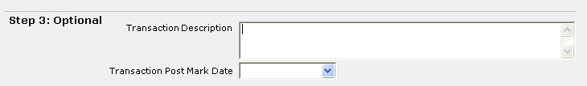

Step 4: Click on the tender payment button

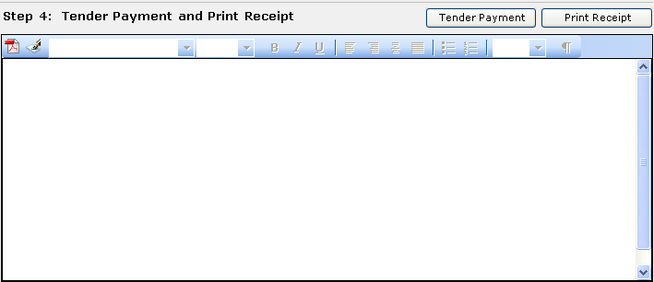

Then you will be able to see your receipt. Make sure you review it carefully to make sure everything is correct. If it is correct, then hit print receipt

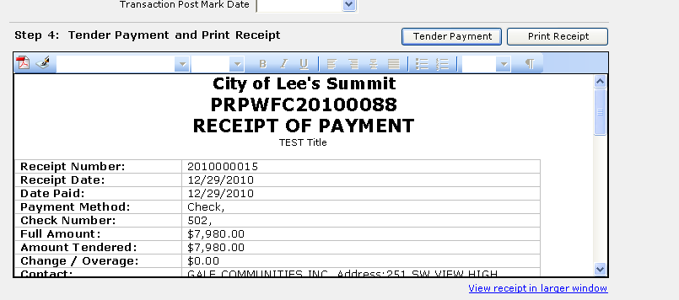

This will pull up a .pdf file for you to print.

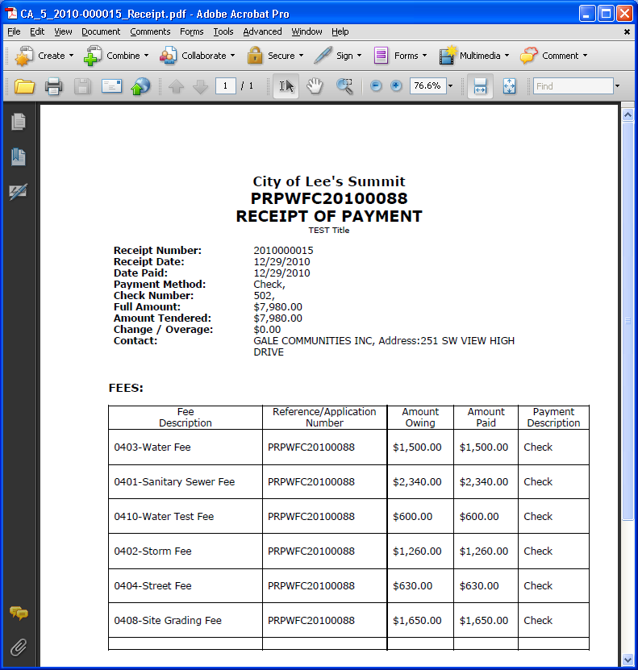

This receipt can now be found as an attachment under the documents and images sheet in the Cashiering binder. In case you need to go back later to view it or reprint it.

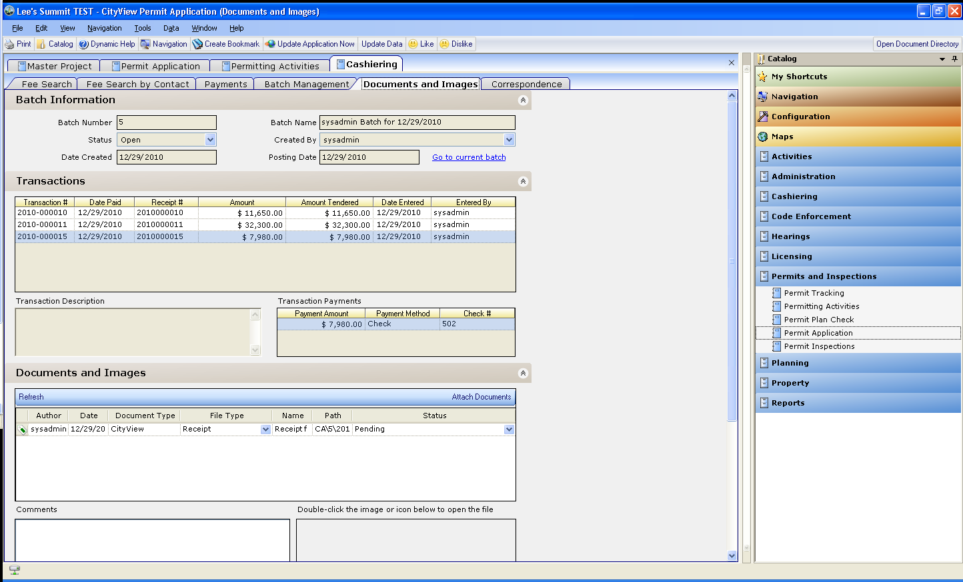

Just put your cursor here and the .pdf icon will show up here for you to double click to open.

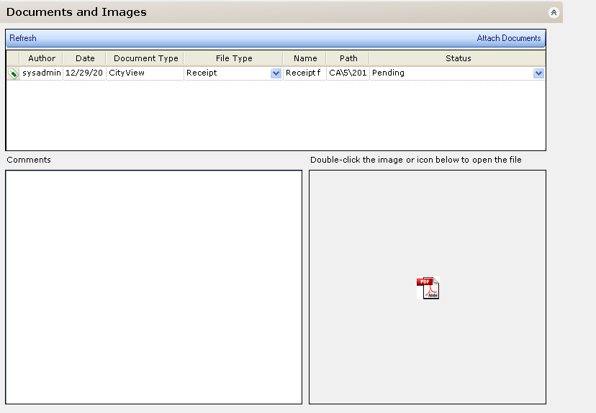

Now you have completed the payment process. So you need to go back to your activities grid. You can do this by clicking the Permit Activities Binder

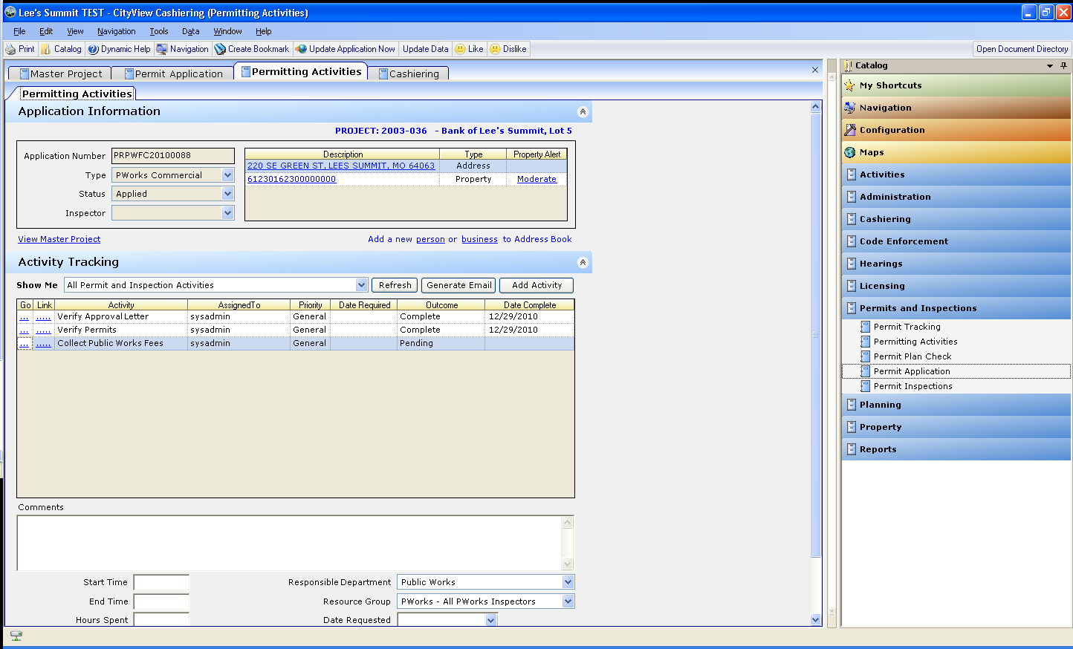

You now need to complete the “Collect Public Works Fees” activity by clicking the complete outcome

Once you have done this, you will now have a new activity to “Issue PW Inspection Permit”

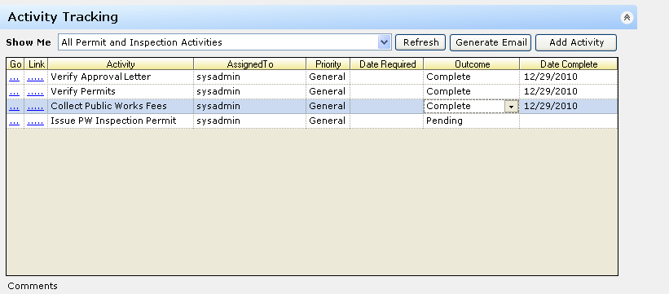

Click on the “Go” blue bar

This will take you to the Correspondence sheet within the Permit Plan Check Binder

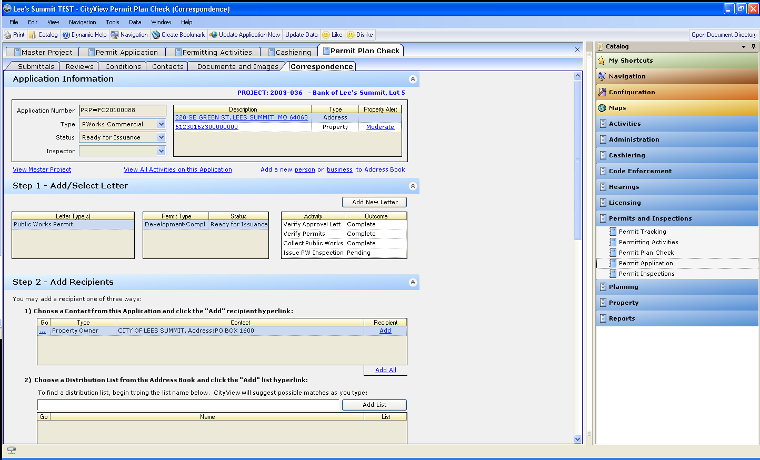

You will see your Public Works Permit automatically under the letter types box

Go to Step 2: You will need to add a recipient for the permit.

Your list of contacts for this app will show up in this list. Choose the one you want by clicking blue “add”

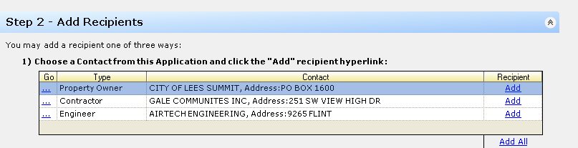

You do not need to do anything with distribution lists

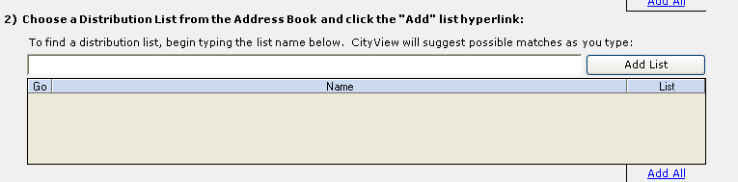

By clicking that blue add button above, this will automatically fill your Step 3 recipient details box for you

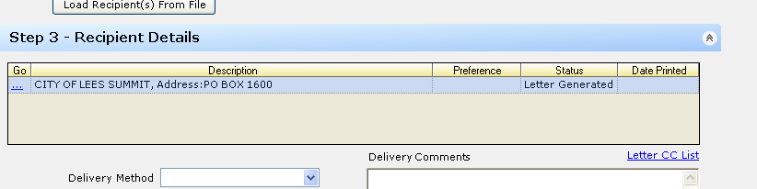

Now go to Step 4: You will now see your permit. Verify everything is correct.

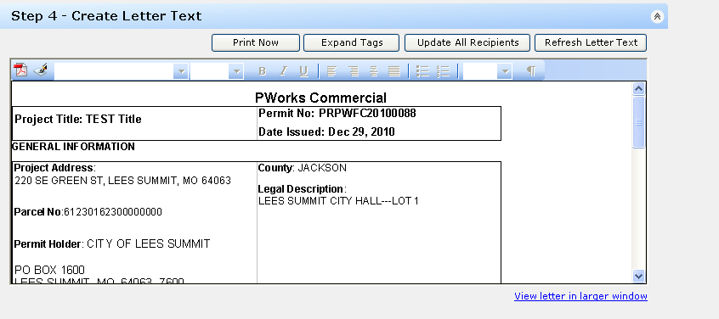

Once you have verified all is correct, click the “Print Now” button

This will create the .pdf of the Permit for you to print.

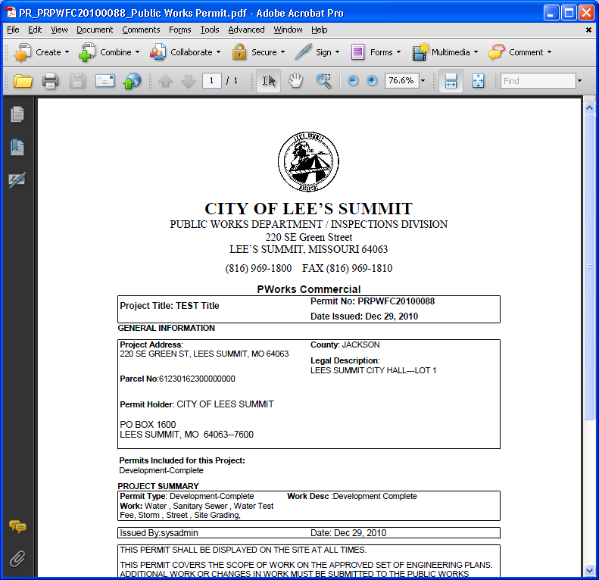

Remember, this .pdf will also be placed under documents and images for future reference or printing. You just need to place your cursor here then click the pdf

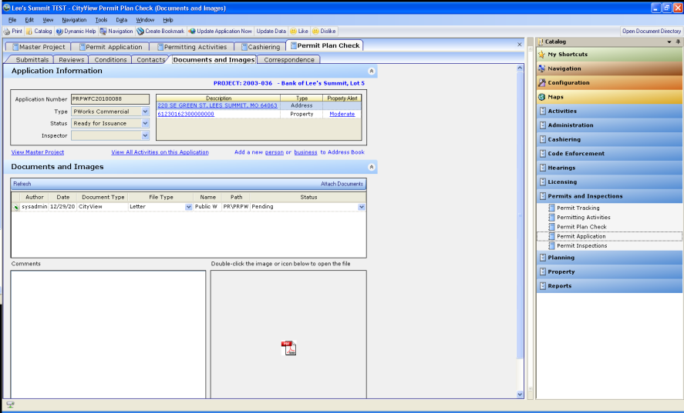

We do not use the deposits and bonds sheet, the conditions sheet, or the cloning sheet.

Remember, the documents and images sheet will allow you to store files associated to the application. It will also show you any documentation you have produced through CV.

There is a difference in how you open up historical attachments vs. newly attached documents.

If you need to open an attachment that was done in PPlus via OfficeLink, you will need to put your cursor in the path box –

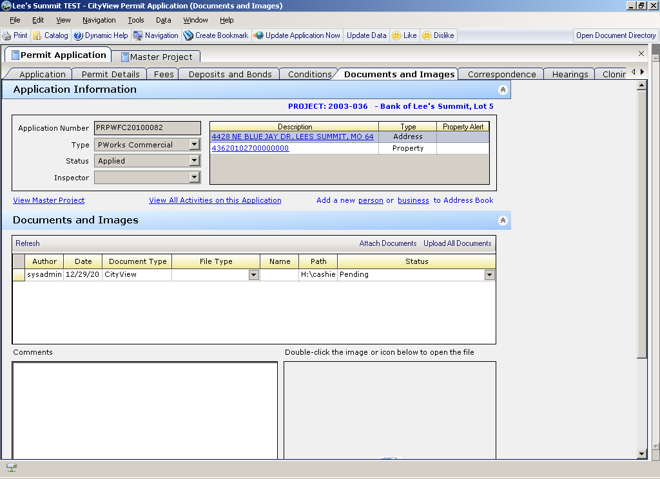

Then click the Open Document Directory

If you are trying to open a document you just attached, there will be an icon in this box. Simply double-click it

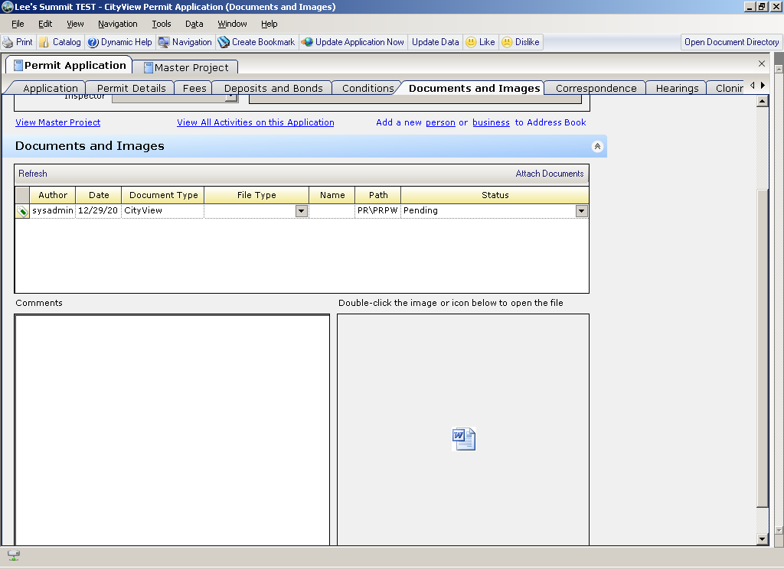

If you have multiple documents attached to an application, you will need to make sure you have your cursor on the one you want to open in the grid

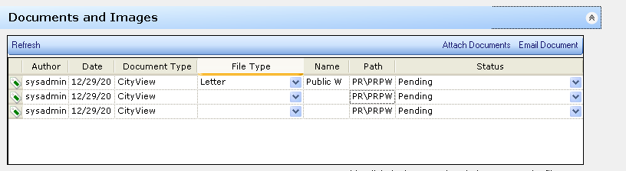

Before double clicking the .pdf or .doc icon

If you can’t tell the .pdf or .doc name, simply click and drag the path bar over further

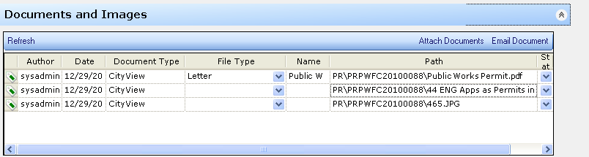

Now you will need to go back to your activities grid by clicking the blue “view all activities on this application link

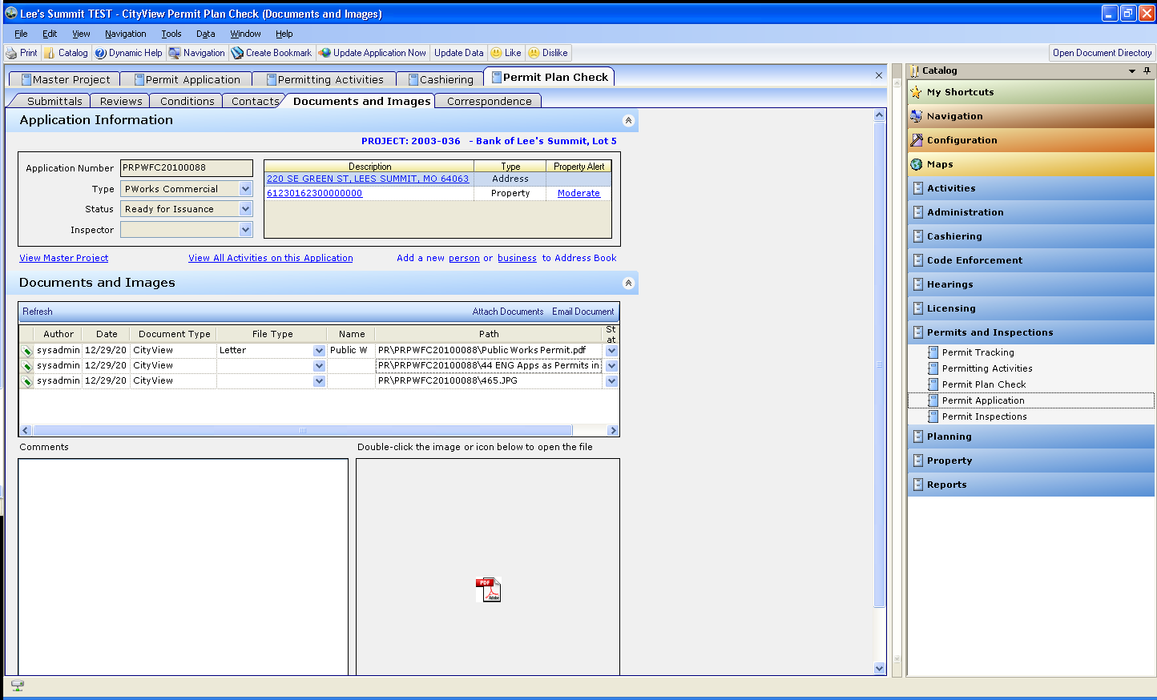

This will take you back to the activities grid so you can complete the “Issue PW Permit” activity

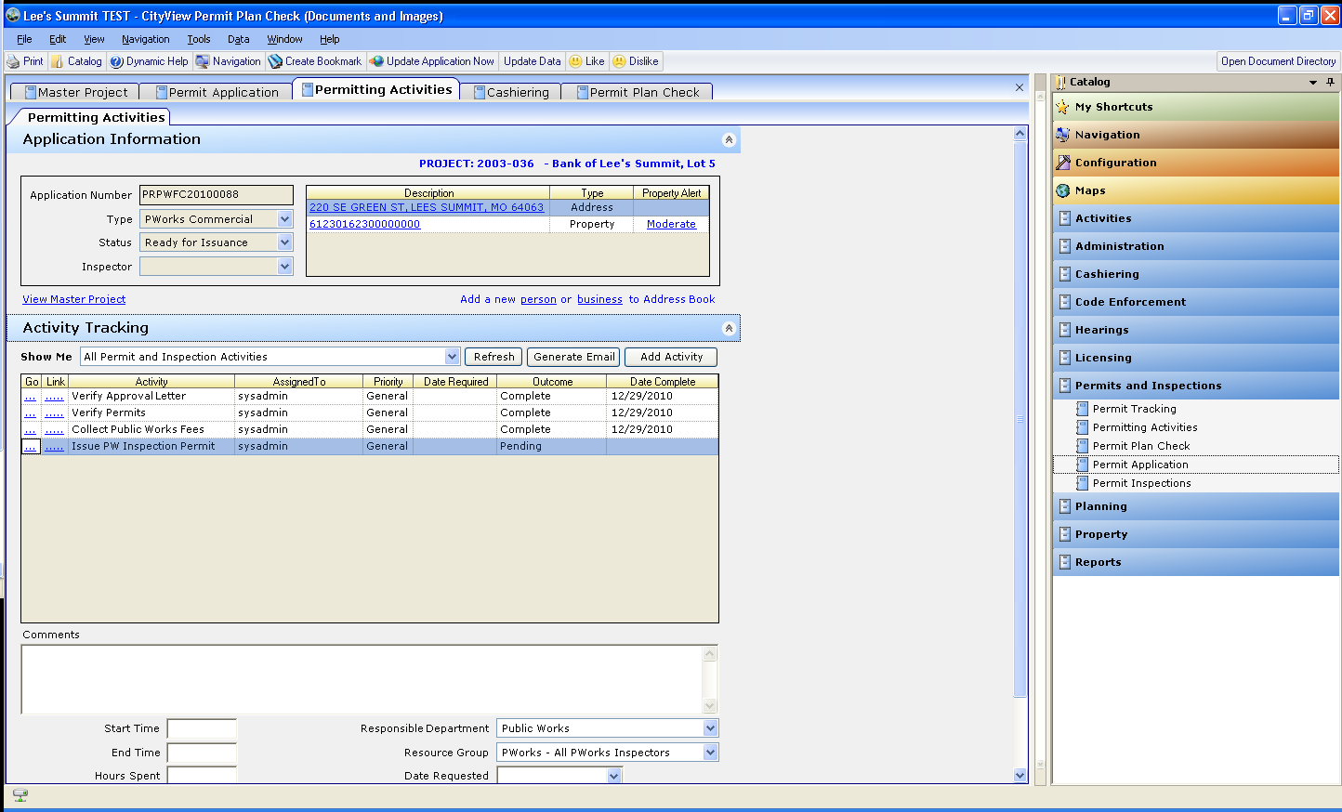

Once you complete this activity, it will generate MANY more activities. These are the inspection activities. This will take a fair amount of time to process. Once it is done processing, the activities grid will look like this

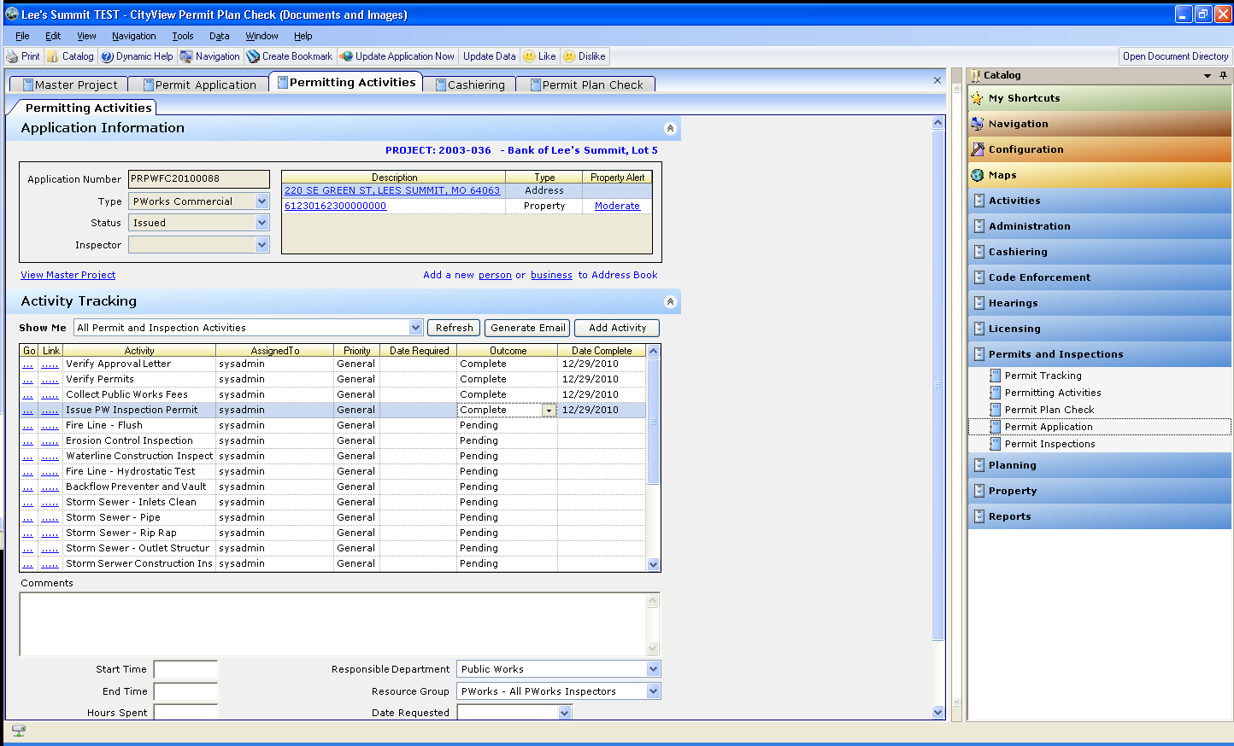

More documentation to come on how to perform inspections in CityView.