Issuing the Permit

From the activity grid, select the go link

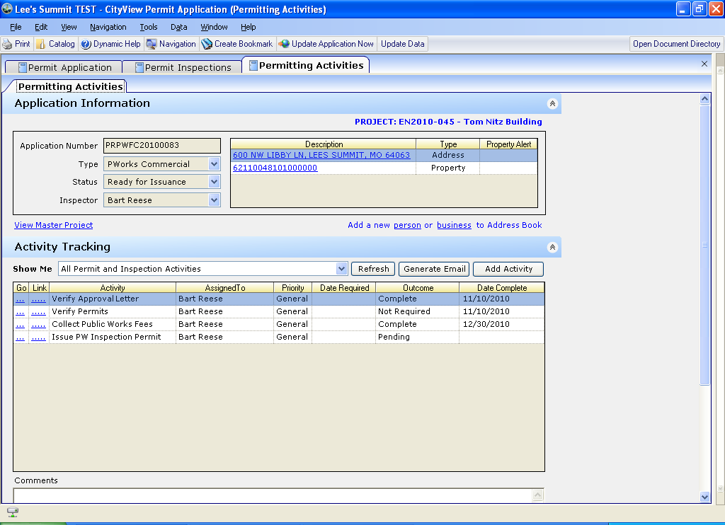

This will take you to correspondence to issue the permti
Select the pworks permit
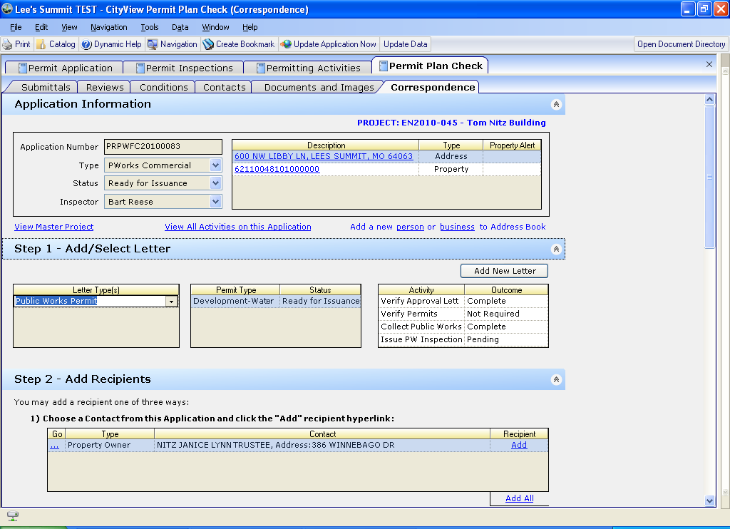
Choose your recipient
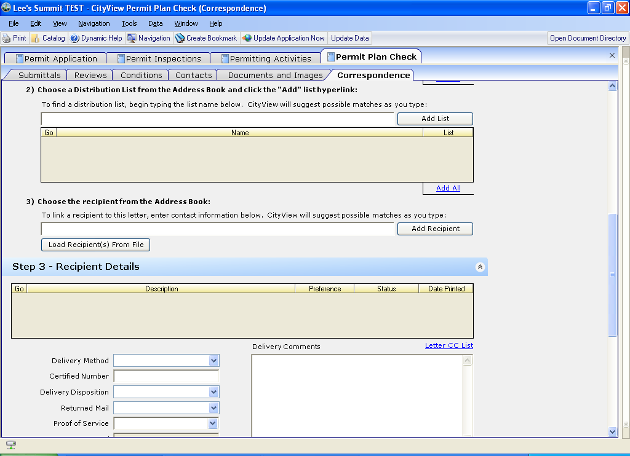

If you would like to view it before printing, select the .pdf This is a view only option
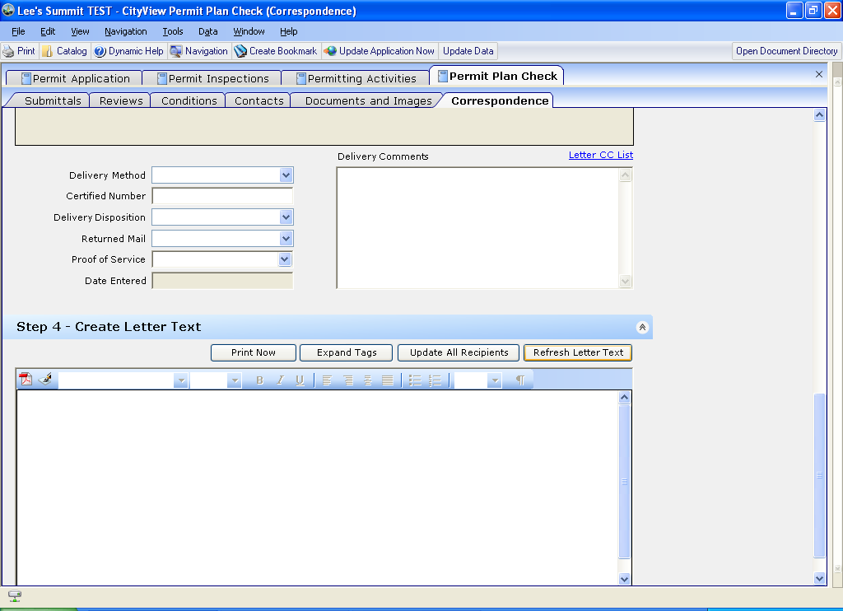
When you are ready to print, print using the print now button

Then go back to your activities sheet to complete this task
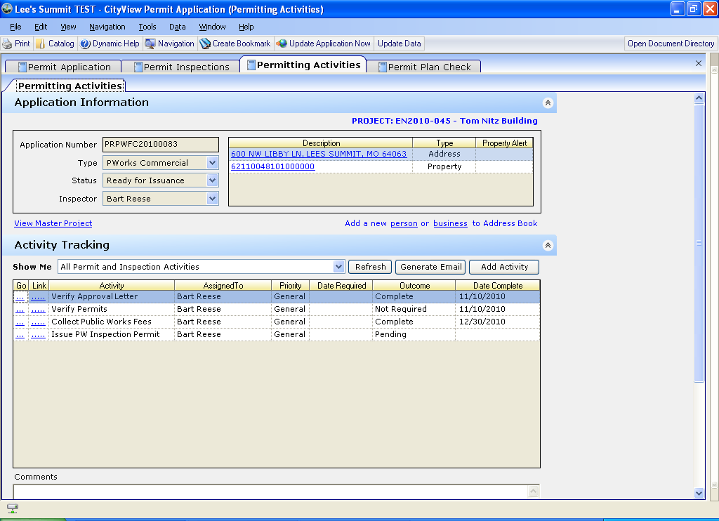

Several items will now show in your activities list –
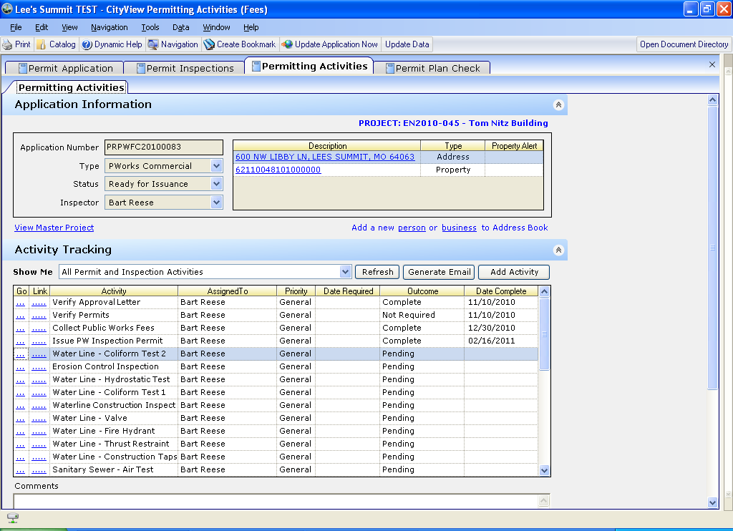

If by chance you need to delete a certain activity, simply highlight that activity and right click on it. Go down to data, delete the current record from GNActivities
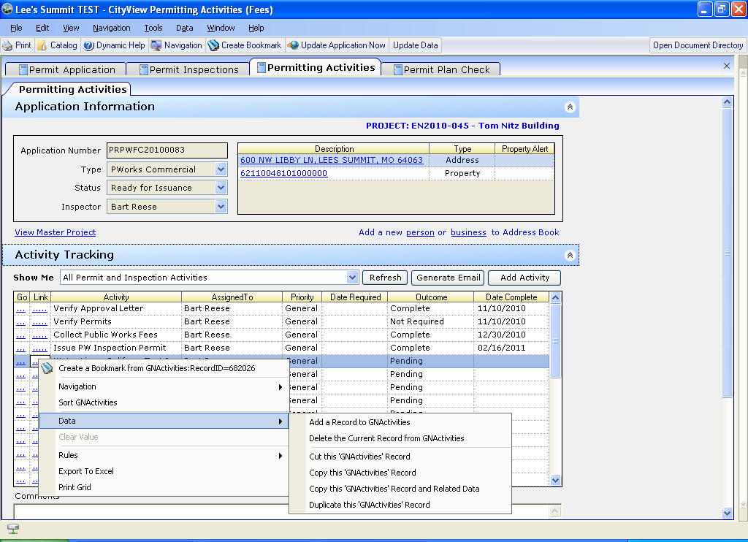

You can customize your activity grid by adding new activities
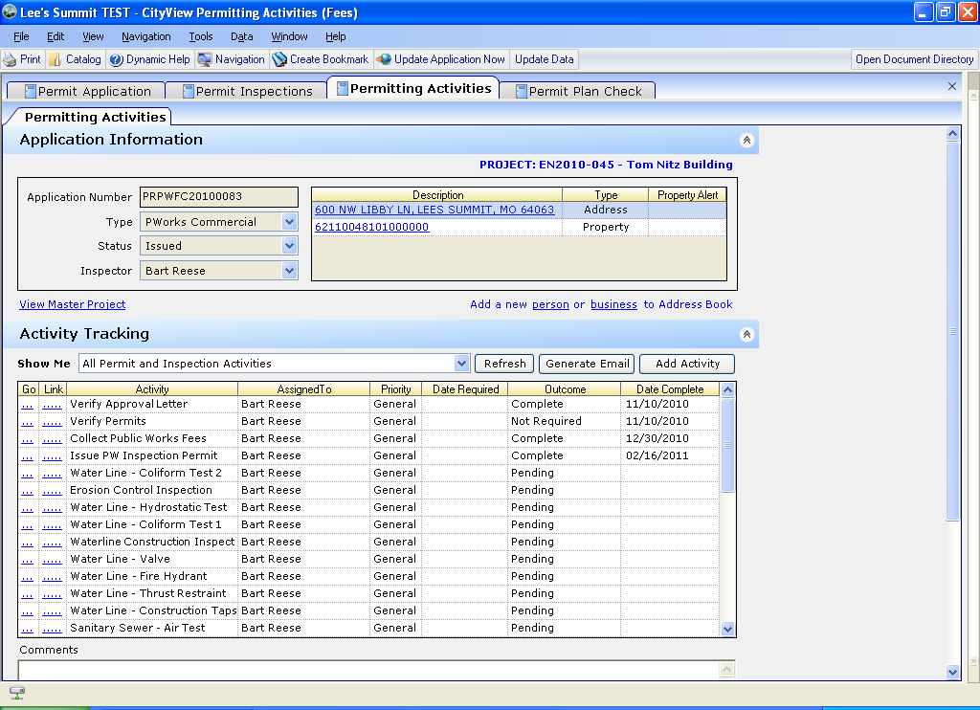

Now you can begin performing your inspections
Hit your go link to have CV take you into the inspection
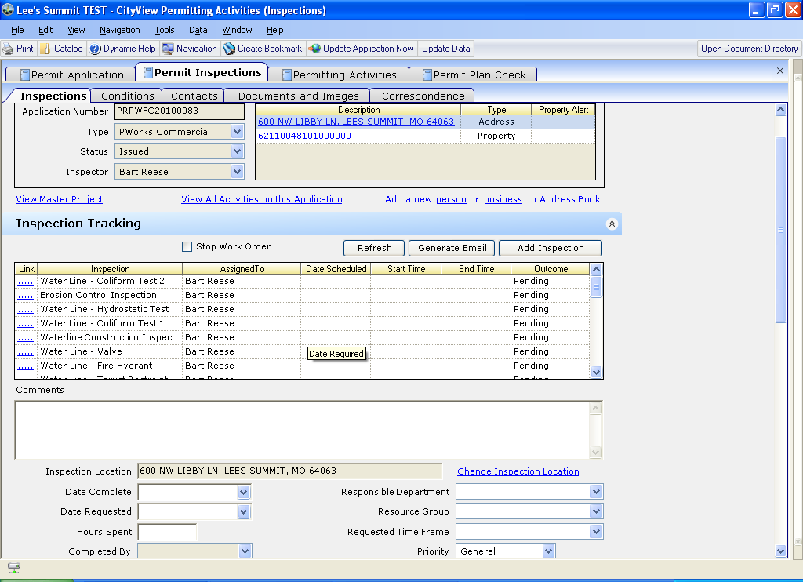

Now you are in the Permits Inspections sheet
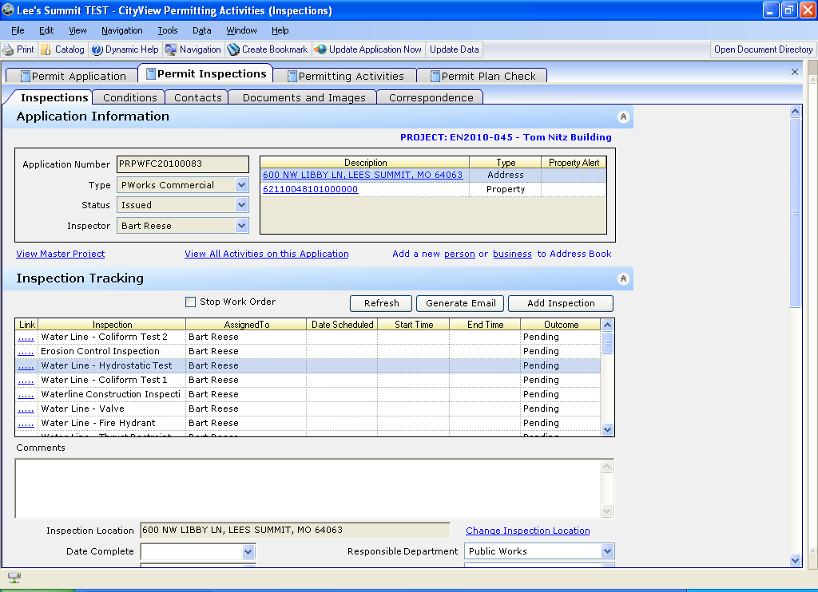

This sheet is where your checklists and corrections are. This enables you to enter or perform pertinent items.
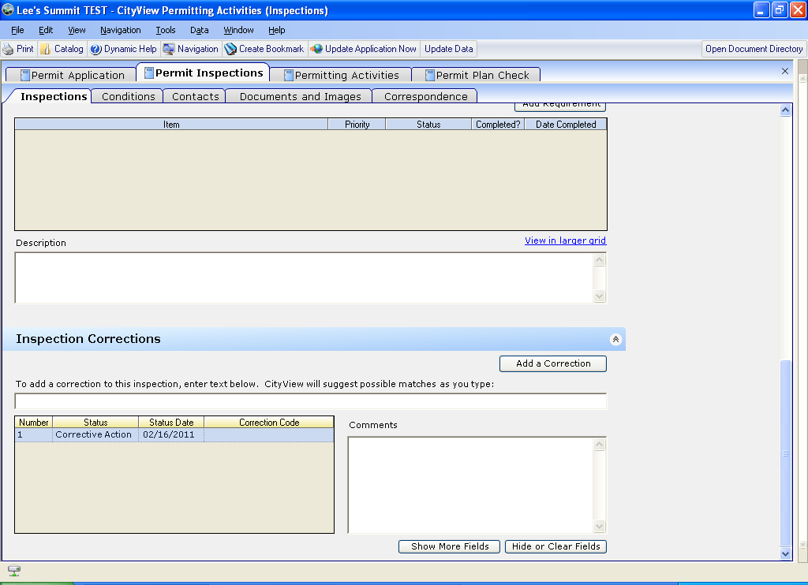
Add any corrections here
If you want to edit any verbage that shows up here – just put your cursor in there and begin typing or deleting what you want
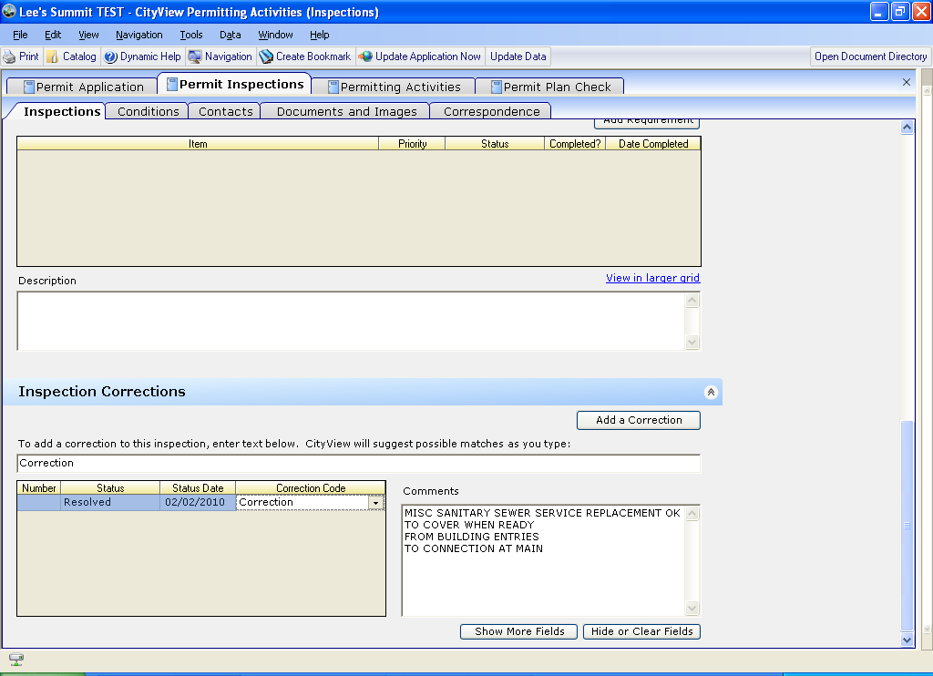
*NOTE!
If you need to add corrections to an inspection and FAIL it. Make sure you add the corrections FIRST then change the outcome of the inspection to failed.
Now you will need to fail your inspection type
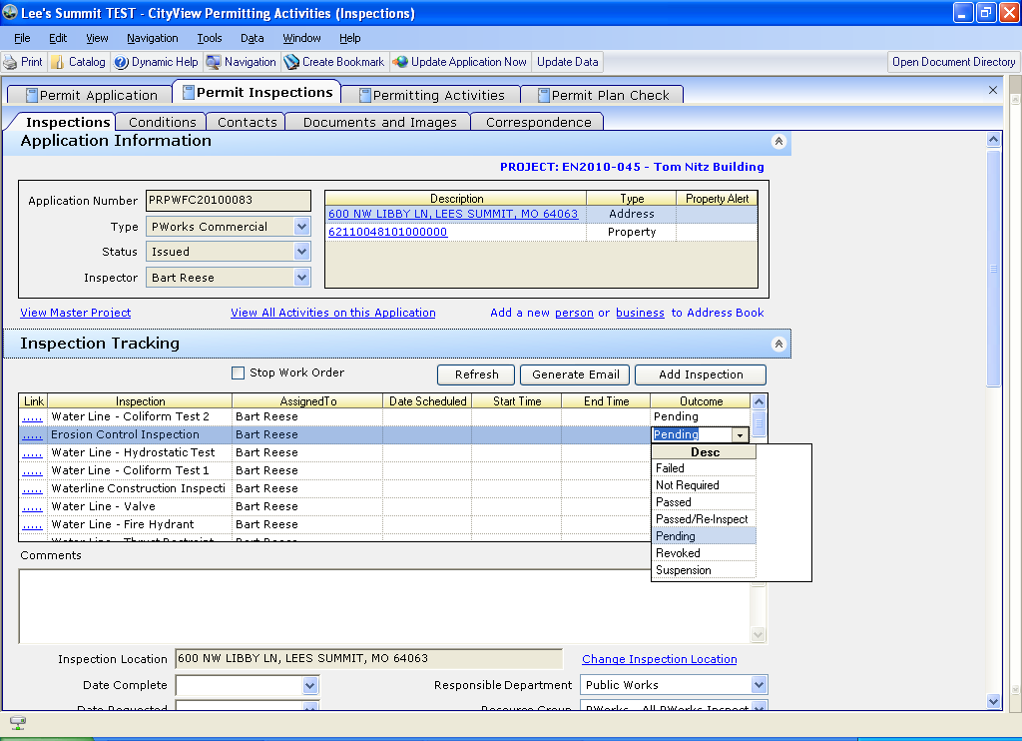
This will then generate a new erosion inspection since you failed it.

Now you will want to go print your inspections report-
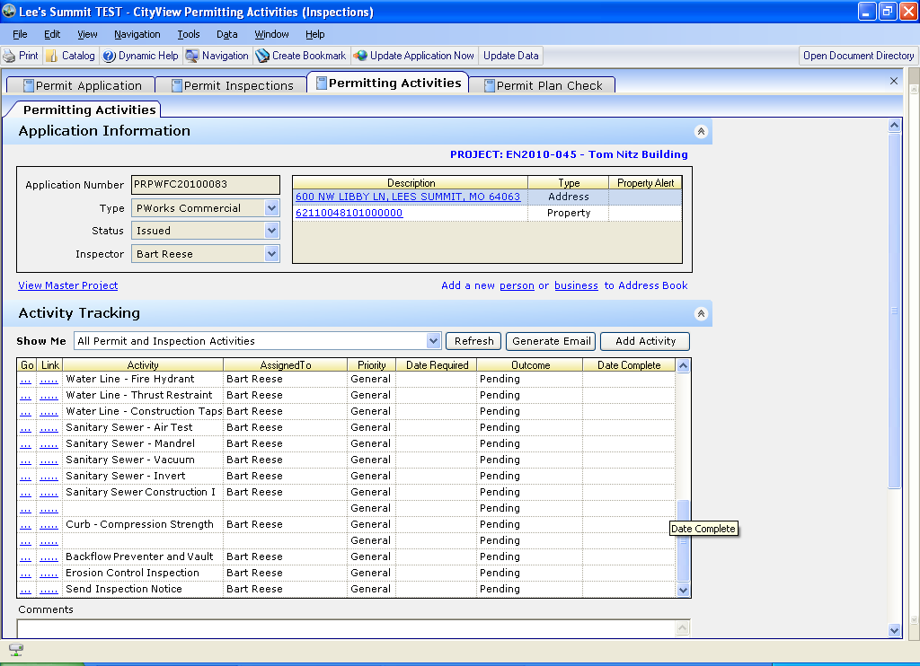
Go back to your activity grid, find send inspections notice and hit the go link
It will take you to correspondence to print the inspections notice
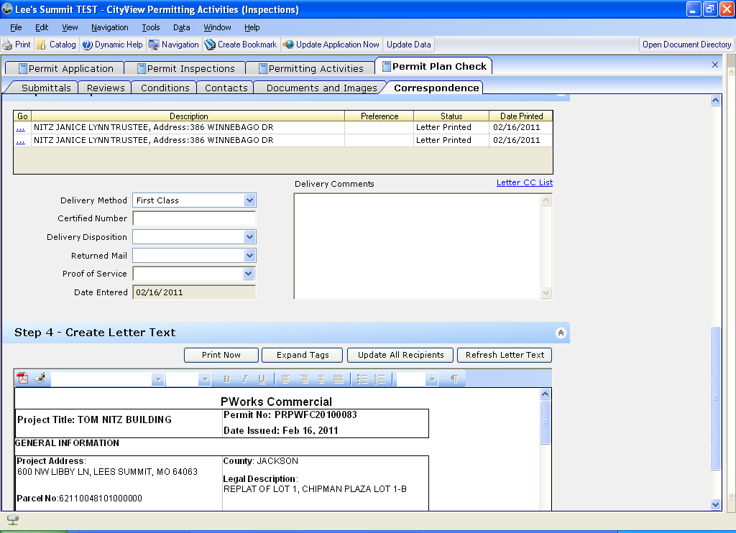
Make sure you add your recipient and hit the print now.
Now go back to your activities grid to complete the activity
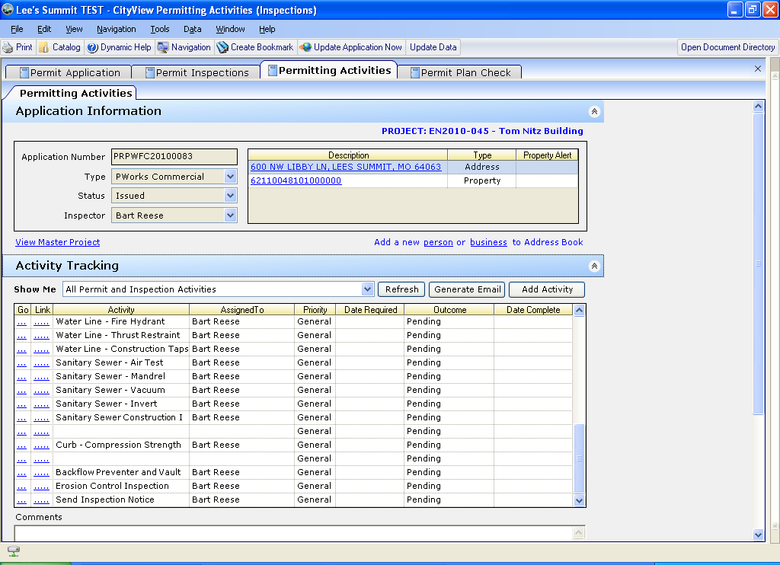

Then the next week you will come back to do your reinspection which will have automatically been added.

If you want to specifically schedule an inspection for a certain day for yourself - simply click on the assigned to and the date scheduled to assign to yourself and the date that you want –

Notice for certain inspection types, you will have checklist items to enter
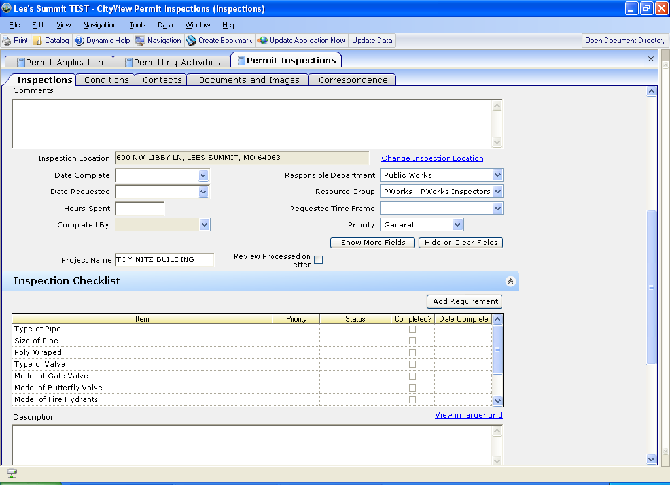
Use the description field for each entry to capture info
You will need to make sure you select each item that you are wanting to add information

Then you can add corrections, fail the inspection, it will create a new inspection and it will create a print inspection notice activity.

The next step after completing and passing inspections, you will need to go to your activities grid for that permit and generate punch list (click go)–
This will take you to correspondence for you to add the recipient and print the punch list

Make sure you select the punch list
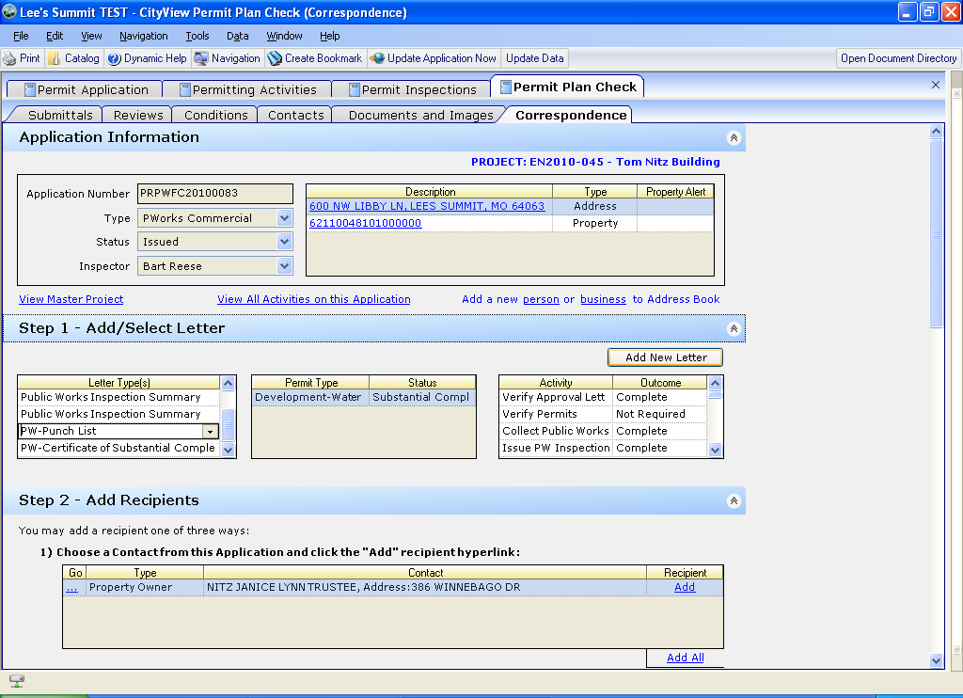

Then print the doc
Now you can go back to your activities grid to issue the Letter of substantial completion – by clicking go and then printing this letter. Make sure you set the activity to complete when you are done. The next activity will be notifications that you have actually issued the substantial completion. Once completing the notifications activity, the generate punchlist will have a 90 day date requested.
Keep in mind the overall status of the permit will be updating upon you working through the activity grid.
Once everything is complete –
You will get an issue final acceptance activity - which is a letter again.
Upon completing this activity, you will have completed your permit.

